Report: Laboratory work 1

Relationship between solar radio flux F10.7 and sunspot number

Team #1: Viktor Liviniuk, Alina Liviniuk, Sergei Vostrikov

In this work we processed data of monthly mean solar radio flux F10.7 and sunspot number from 1940s to 2010s years.

On the next 2 pictures data is represented as plots, also 13-month smoothed data is shown.

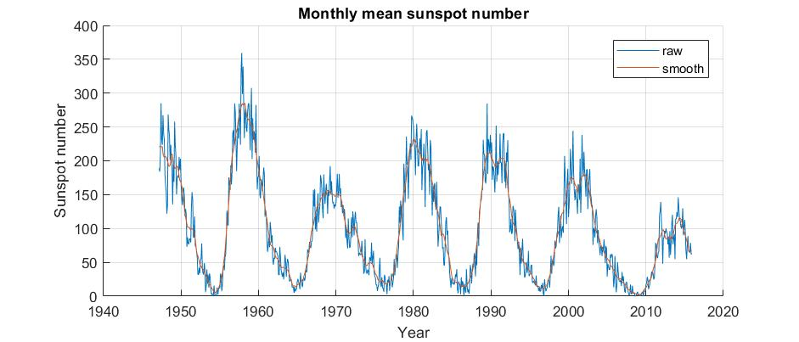

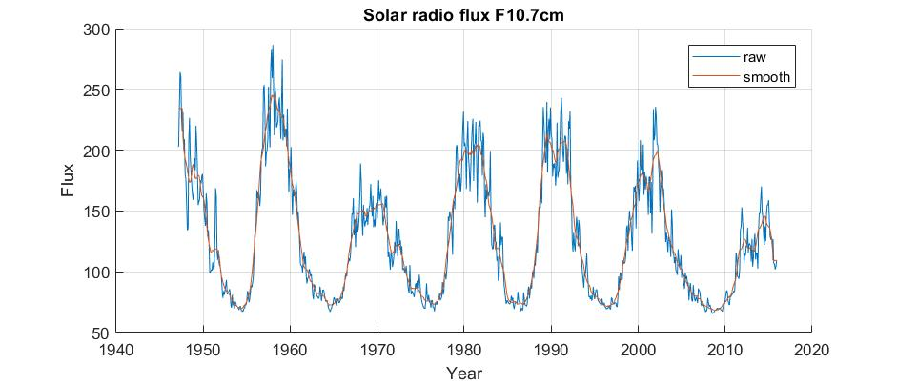

Next plot demonstrates, that there clearly is a correlation between 2 main indicators of solar activity.

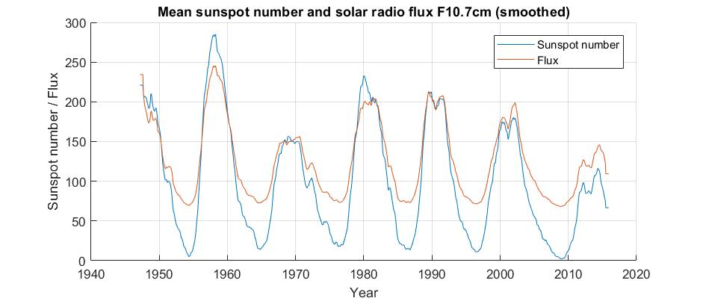

To understand this relationship, we constructed a multi-dimensional linear regression, used LSM. Then reconstructed solar radio flux at 10.7 cm on the basis of sunspot number, using the regression equation. The variance of estimation error of solar radio flux at 10.7 was 𝜎2 = 42.77. It is shown on the following graph.

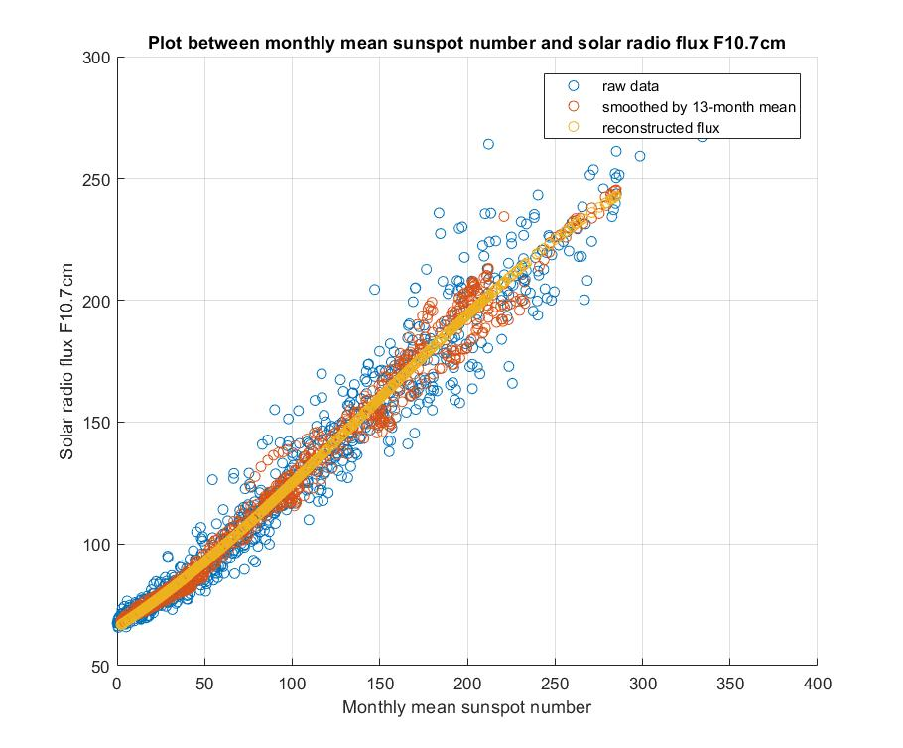

Conclusions. Solar radio flux at 10.7 cm can be determined on basis of sunspot number. It is very convenient to use MatLab software to process data. For example, for using LSM on big sets of data and constructing of multi-dimensional linear regression, like it was performed during this laboratory work.

Files with the matlab code are attached.